Lab 06 – Worksheet

Name: Myrah Hussain  Romaisa Shazad | ID: rb10107  mh10074 | Section:

Note: Assumptions and logics should be explained separately in tasks after the task results.

Task 1
Block Diagram
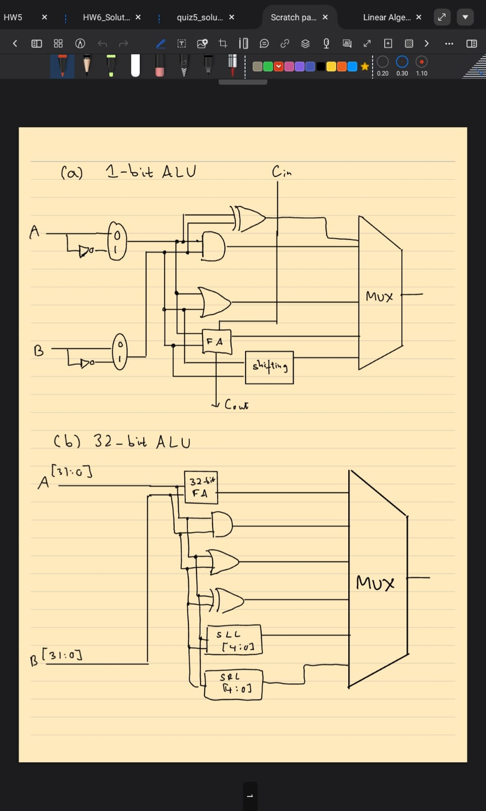

Comments

Task 2

Modules + Testbench:
ALU:
module ALU (
input [31:0] A, B, // 32-bit inputs
input [3:0] ALUControl, // Control signal
output reg [31:0] ALUResult, // Result of the operation
output Zero // Zero flag for branching
);

// The Zero flag is high if ALUResult is exactly 0
assign Zero = (ALUResult == 32'b0);

always @(*) begin
case (ALUControl)
4'b0000: ALUResult = A & B; // AND
4'b0001: ALUResult = A | B; // OR
4'b0010: ALUResult = A + B; // ADD
4'b0110: ALUResult = A - B; // SUB
4'b0100: ALUResult = A ^ B; // XOR
4'b0101: ALUResult = A << B[4:0]; // SLL (Shift by lower 5 bits of B)
4'b0111: ALUResult = A >> B[4:0]; // SRL
default: ALUResult = 32'b0; // Default case
endcase
end
endmodule

ALU testbench:
`timescale 1ns / 1ps // Defines time unit and precision

module ALU_tb();
//Declaring local signals
reg [31:0] A, B;
reg [3:0] ALUControl;
wire [31:0] ALUResult;
wire Zero;

// 2. Instantiate

ALU uut (
.A(A),
.B(B),
.ALUControl(ALUControl),
.ALUResult(ALUResult),
.Zero(Zero)
);

// 3. Stimulus Generation
initial begin
// Display a header in the simulation console
$display("Time\t A\t B\t Ctrl\t Result\t Zero");
$monitor("%0t\t %h\t %h\t %b\t %h\t %b", $time, A, B, ALUControl, ALUResult, Zero);

// Test Case 1: ADD
A = 32'h0000000A; B = 32'h00000005; ALUControl = 4'b0010;
#10; // Wait 10ns

// Test Case 2: SUB
A = 32'h00000014; B = 32'h00000004; ALUControl = 4'b0110;
#10;

// Test Case 3: SUB (Zero Flag Check)
A = 32'h000000FF; B = 32'h000000FF; ALUControl = 4'b0110;
#10;

// Test Case 4: SLL (Shift Left 2 bits) -
// 0x1 becomes 0x4 (0001 -> 0100)
A = 32'h00000001; B = 32'h00000002; ALUControl = 4'b0101;
#10;

// Test Case 5: AND
A = 32'hFFFF0000; B = 32'h0000FFFF; ALUControl = 4'b0000;
#10;

$finish;
end
endmodule

Results:
Waveform:
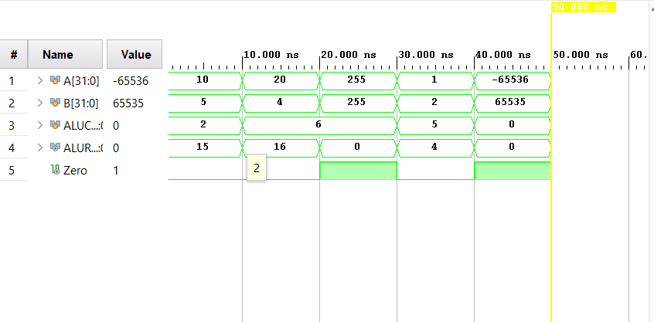

Task 3

RTL Schematics

Lab 05 – Designing FSM Using FPGA Switches and LEDs

Assessment Rubrics

Points Distribution
Task No. | LR2  Code | LR 5  Results | LR11  Design | AR7
Task 1 | - | - | /20 | /20
Task 2 | /20 | /15
Task 3 | /10 | /15
Total Points | /80 |  |  | /20
CLO Mapped | CLO 1
For description of different levels of the mapped rubrics, please refer the provided Lab Evaluation Assessment Rubrics and Affective Domain Assessment Rubrics.
# | Assessment Elements | Level 1: Unsatisfactory  Points 0-1 | Level 2: Developing  Points 2 | Level 3:Good  Points 3 | Level 4:Exemplary  Points 4
LR2 | Program/Code/ Simulation Model/ Network Model | Program/code/simulation model/network model does not implement the required functionality and has several errors. The student is not able to utilize even the basic tools of the software. | Program/code/simulation model/network model has some errors and does not produce completely accurate results. Student has limited command on the basic tools of the software. | Program/code/simulation model/network model gives correct output but not efficiently implemented or implemented by computationally complex routine. | Program/code/simulation /network model is efficiently implemented and gives correct output. Student has full command on the basic tools of the software.
LR5 | Results & Plots | Figures/ graphs / tables are not developed or are poorly constructed with erroneous results. Titles, captions, units are not mentioned. Data is presented in an obscure manner. | Figures, graphs and tables are drawn but contain errors. Titles, captions, units are not accurate. Data presentation is not too clear. | All figures, graphs, tables are correctly drawn but contain minor errors or some of the details are missing. | Figures / graphs / tables are correctly drawn and appropriate titles/captions and proper units are mentioned. Data presentation is systematic.
AR9 | Report | All the in-lab tasks are not included in report and / or the report is submitted too late. | Most of the tasks are included in report but are not well explained. All the necessary figures / plots are not included. Report is submitted after due date. | Good summary of most the in-lab tasks is included in report. The work is supported by figures and plots with explanations. The report is submitted timely. | Detailed summary of the in-lab tasks is provided. All tasks are included and explained well. Data is presented clearly including all the necessary figures, plots and tables.

